Title in Arial Bold, 16 pt, line spacing 21 pt, justified (centered), 8 pt space after
Ron Smith ¹, Anne Brown ² and Jane Doe ³
¹Department of Serendipitous Research, Lund University, Lund, Sweden
²Science Institute, Umeå, Sweden
³Faculty of Behavior Studies, Karolinska Institute, Stockholm Sweden
Times New Roman Italic, size 11 pt on 15 pt, centered.
Replace dummy text/names/figures/tables with your own text/names/figures/tables.

Abstract (Arial 12 pt bold italic)
The abstract goes here. Maximum of 150 words. Times New Roman Italics, size 11 pt, margin adjusted.

Section Header 1 (Arial 12 pt bold)
This template is likely to work properly in MS Word for Windows and Mac. A simple way of using it consists in substituting one’s own text for this one. The first line of each paragraph is indented by 5 mm, as in this example.
The text is written in Times New Roman, size 11 points. The paper margins are 20 mm on all sides. Column width is 81.4 mm with 7 mm between the columns. The text is both right and left justified.
Endnotes1 may be used, but see the section “Notes” below for more information.2

Subsection Header 2 (Arial 11 pt bold italic)
Then the text begins again. Citations should appear with surname(s) and year with parentheses (Fant, 1960) or Fant (1960) or Fant (1960:34). Separate multiple citations with a semi-colon (;). Please note that page numbers should be given whenever a specific piece of information is given, and not the entire work.

Subsection Header 2 (Arial 11 pt bold italic)
The subsection heading is the lowest level heading permitted in the document.
For phonetic symbols and text that includes non-Latin1 letters, use of i2speak is recommended; see http://www.i2speak.com, an online phonetic keyboard. For phonetic symbols in headings, use Arial Unicode MS. Alternatively, use an IPA Character picker.
Figures and tables may be added as a column-wide items (see Figures 1 and 2 and Table 1) or as column-spanning items (see Table 2 and Figure 3). It is recommended to use sans-serif fonts (e.g., Arial, Tahoma) in tables at a font size that is not too small for legibility.
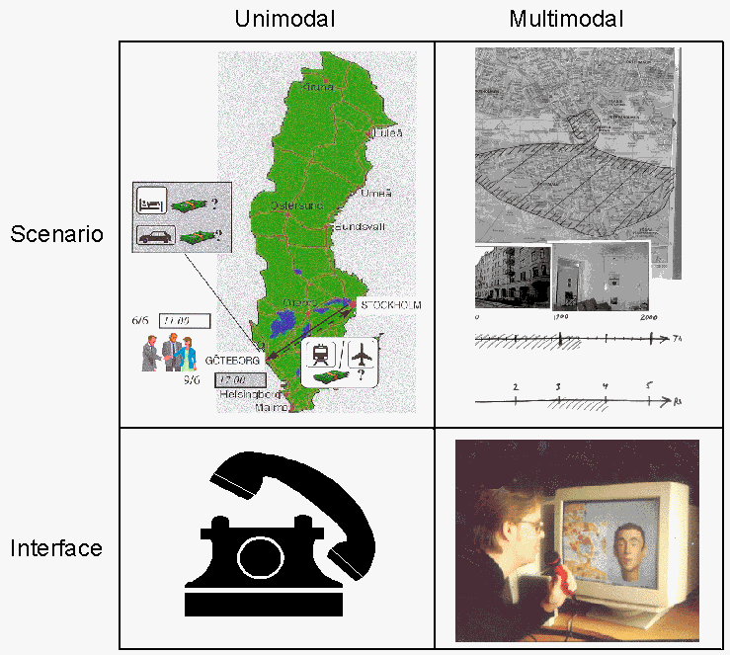
Figure 1. A figure caption is placed below the figure using Times New Roman Italics, size 10 pt, margin justified, 6 pt space before.
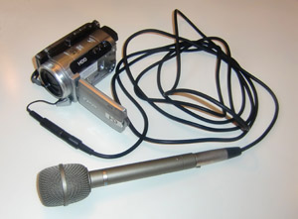
Figure 2. A figure caption is placed below the figure using Times New Roman Italics, size 10 pt, margin justified, 6 pt space before.
Color figures as well as shading in tables are all possible, but it is advised to make sure that they are still readable if printed in grayscale.
Table 1. Table headings are always written above the table, whereas captions to figures are written below the figures. Text is written in Times New Roman Italics, size 10 pt with a 6 pt space after.
 | Var 1 | Var 2
No. subjects | 16 | 16
No. something | 602 | 847
No. something else | 413 | 799
No. something else again | 4,013 | 5,829
Percentages | 41.8% | 34.3%
Other percentages | 61.0% | 36.4%

Section Header 1 (Arial 12 pt bold)
The length of the submitted version of the paper must not exceed five (5) pages, where the fifth page may consist only of references. After review, authors of accepted papers will be allowed one additional page in order to deal with reviewers’ comments; hence, 6 pages for the final version, where the sixth page may consist only of references. Papers should be submitted electronically in both pdf-format and docx formats (for editing) no later than March 15, 2021.
In sed interdum tellus. Donec et ipsum mauris. Pellentesque non ligula fringilla, aliquam velit sit amet, vehicula leo. Sed sagittis mi et mauris pulvinar, a sagittis nulla tempor. Nunc molestie sem id congue aliquet. Proin nec tincidunt elit, in pulvinar lorem. Praesent rhoncus ex hendrerit, venenatis ex quis, sollicitudin nunc.
Table 2. Table headings are always written above the table, whereas captions to figures/plates/photos are written below the figures. Text is written in Times New Roman Italics, size 10 pt with a 6 pt space before. EXAMPLE OF TABLE SPANNING TWO COLUMNS, IF DESIRED (IF NOT: DELETE)
 | Variable 1 |  | Variable 2 |  | Variable 3 |  | Variable 4
Phonation type | Ingressive | Egressive | Ingressive | Egressive | Ingressive | Egressive | Ingressive | Egressive
No. phases analysed | 69 | 70 | 8 | 8 | 29 | 29 | 109 | 107
Mean duration (ms) | 2014 | 2774 | 1537 | 2000 | 2426 | 2120 | 1819 | 1401
Mean duration egr+ingr (ms) | 2397 |  | 1768 |  | 2273 |  | 1612
Standard deviation | 309.3 | 515.7 | 518.8 | 588.1 | 300.5 | 193.9 | 254.1 | 163.5
Maximal duration | 2800 | 3700 | 2600 | 2850 | 3200 | 2500 | 3320 | 1830
Minimal duration | 1300 | 1200 | 900 | 900 | 2000 | 1700 | 940 | 670
Δ t test (paired-samples, two-tailed) | p < 0.001 |  | p = 0.011 |  | p < 0.001 |  | p < 0.001
Δ Wilcoxon (two related samples) | p < 0.001 |  | p = 0.027 |  | p < 0.001 |  | p < 0.001

Section Header 1 (Arial 12 pt bold)
In order to maintain layout consistency across papers, certain formatting features have been locked in this template. You can easily set the formatting for components of the text by applying the following MS-Word styles to the relevant portions of your document: Paper title, Author, Abstract heading/text, Section/Subsection heading, Paragraph, List paragraph, Figure/Table caption, Endnote, and Reference. Character styles may also be useful: Endnote number as well as Emphasis for italics and Strong for bold face.
Integer consectetur tincidunt nisi. Aliquam erat volutpat. Nam consequat quis metus egestas vulputate. Praesent rhoncus ex hendrerit, venenatis ex quis, sollicitudin nunc. Pellentesque tincidunt malesuada massa vitae gravida. Donec ac faucibus est, sit amet lacinia tellus. Class aptent taciti sociosqu ad litora torquent per conubia nostra, per inceptos himenaeos. Aliquam tempor tincidunt dignissim.
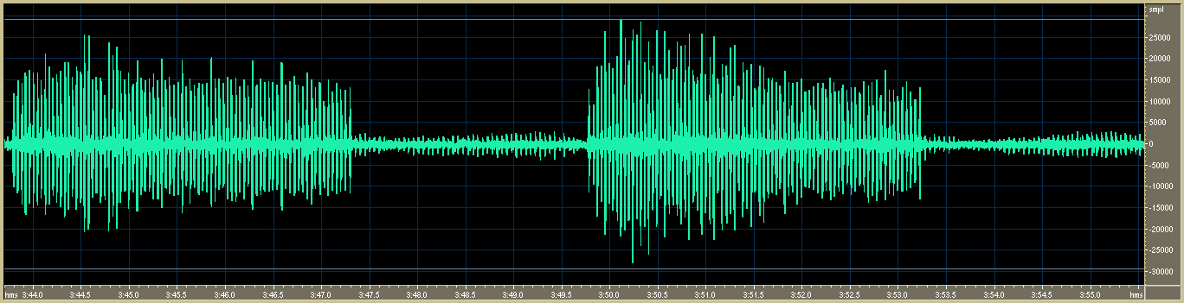
Figure 3. Figures and tables can also stretch across the entire page. IF NOT DESIRED: DELETE.

Sed in felis a massa condimentum consectetur ac ut mi. Aliquam nibh nunc, accumsan ultrices turpis ac, interdum auctor metus. Integer fermentum euismod elit, ut dictum justo consequat quis. Nullam vel efficitur nunc, vitae malesuada ligula. Morbi vitae congue nunc, sed consequat nunc. Nunc lacinia nisl urna, eget lobortis felis consequat eu. Ut congue viverra justo, a volutpat mi pulvinar in. Vestibulum ante ipsum primis in faucibus orci luctus et ultrices posuere cubilia Curae; Fusce pretium dui eu enim egestas imperdiet. Duis rutrum et nibh eu sollicitudin. Maecenas at consectetur augue, nec consectetur diam. Fusce pretium dui eu enim egestas imperdiet.

Paper evaluation
Papers will be evaluated by at least two reviewers who will judge them on the following points.
- Originality (e.g., does the paper present something new; or something old in a new or innovative way?)
- Scholarship (e.g., does the paper review the relevant background; does the paper use sound research methods?)
- Clarity (e.g., is the paper easy to read; is the research question motivated and defined clearly; are results and argumentation given in a transparent manner?)
- Scientific contribution (e.g., what value does the work add to the study of disfluency)
- Format (e.g., is the paper laid out following typical scientific formats; does it follow the provided template; are citations and references organized and complete?).
Sed in felis a massa condimentum consectetur ac ut mi. Aliquam nibh nunc, accumsan ultrices turpis ac, interdum auctor metus. Integer fermentum euismod elit, ut dictum justo consequat quis. Nullam vel efficitur nunc, vitae malesuada ligula. Morbi vitae congue nunc, sed consequat nunc. Nunc lacinia nisl urna, eget lobortis felis consequat eu. Ut congue viverra justo, a volutpat mi pulvinar in. Vestibulum ante ipsum primis in faucibus orci luctus et ultrices posuere cubilia Curae; Fusce pretium dui eu enim egestas imperdiet. Duis rutrum et nibh eu sollicitudin. Integer sollicitudin nibh ante, ut iaculis neque porttitor id. Nulla facilisi.
Phasellus urna nulla, elementum a nisi at, luctus congue ex. Mauris posuere suscipit ex quis auctor. Class aptent taciti sociosqu ad litora torquent per conubia nostra, per inceptos himenaeos. Phasellus in arcu in erat consectetur viverra. Ut facilisis ac lorem sed tristique. Sed turpis libero, molestie eu tortor eget, imperdiet auctor turpis. Nunc blandit felis et tortor pulvinar commodo. In hac habitasse platea dictumst. Etiam laoreet vel mi vel malesuada. In molestie, tortor nec commodo sodales, urna nisi eleifend eros, ac dictum arcu libero vitae nulla. Nulla et viverra neque. Integer varius pulvinar sem, ac hendrerit libero dictum eget. Aliquam lorem tortor, luctus vitae leo non, tempus consequat lacus.
Phasellus urna nulla, elementum a nisi at, luctus congue ex. Mauris posuere suscipit ex quis auctor. Class aptent taciti sociosqu ad litora torquent per conubia nostra, per inceptos himenaeos. Phasellus in arcu in erat consectetur viverra. Ut facilisis ac lorem sed tristique. Sed turpis libero, molestie eu tortor eget, imperdiet auctor turpis. Nunc blandit felis et tortor pulvinar commodo. In hac habitasse platea dictumst. Etiam laoreet vel mi vel malesuada. In molestie, tortor nec commodo sodales, urna nisi eleifend eros, ac dictum arcu libero vitae nulla. Nulla et viverra neque. Integer varius pulvinar sem, ac hendrerit libero dictum eget. Aliquam lorem tortor, luctus vitae leo non, tempus consequat lacus.
Fusce nisi odio, finibus in tempor sed, imperdiet vitae risus. Nulla facilisi. Sed cursus mattis augue ac pharetra. Etiam auctor massa quam, ac tincidunt quam fermentum eu. Curabitur consectetur risus sed erat placerat, sed facilisis magna blandit. Cras venenatis nunc nec ultrices convallis. Donec ullamcorper ornare magna ac ultrices. Phasellus tempor urna sit amet pretium accumsan. Nam sed nunc arcu. Suspendisse placerat ullamcorper turpis malesuada venenatis. Integer dolor urna, facilisis ac porttitor ut, dapibus sit amet erat. Ut vestibulum purus ac risus consequat fermentum.
Cras vel elit non lacus mattis venenatis. Etiam id fermentum lacus, vel hendrerit nisl. Aenean sodales nisl dictum tellus ullamcorper, quis imperdiet ex faucibus. Etiam lobortis purus luctus, dictum risus a, condimentum dolor. Quisque sollicitudin a ligula in blandit. Donec a lacus vitae velit tristique malesuada nec et felis. Aliquam purus risus, feugiat non est fermentum, placerat ultrices dui. Vivamus accumsan leo ante, at interdum tellus auctor vel. Suspendisse sit amet euismod felis, in accumsan tortor. Vestibulum in odio sed ipsum dictum euismod ut quis nibh.
Donec rutrum faucibus convallis. Integer id mauris efficitur, porttitor felis id, lobortis orci. Maecenas eu fringilla purus. Donec eget sollicitudin erat, et maximus lacus. Sed metus mi, egestas vel consectetur id, laoreet eget arcu. In vehicula posuere sodales. Quisque nunc ipsum, dictum quis feugiat vel, volutpat sed massa. Maecenas at consectetur augue, nec consectetur diam. Quisque maximus ornare nunc, vel mattis nisl porttitor ut. In mauris lectus, blandit quis purus a, posuere porta leo. Proin auctor a metus ac gravida. Nullam eleifend luctus nisl et laoreet. Mauris nulla purus, feugiat vitae est ut, gravida sollicitudin nunc. Suspendisse id ultrices libero, in volutpat est.
Curabitur sit amet tellus ullamcorper, placerat mi at, aliquam lectus. Nullam ante massa, sodales vel commodo quis, convallis at magna. Aliquam vulputate lacus lorem, in suscipit tellus suscipit vel. Nam sollicitudin rhoncus metus vel bibendum. Nulla tincidunt non tortor ac laoreet. Vivamus dignissim nisl urna, sed viverra elit porta sed. Nullam vestibulum fermentum enim. Donec egestas tortor in varius commodo. Proin congue, mauris non volutpat malesuada, massa eros tincidunt massa, tempus tristique magna urna et enim. Curabitur iaculis semper nisl ut facilisis. Donec et venenatis purus. Pellentesque velit dui, gravida sed purus at, rhoncus pellentesque ex. Ut et luctus dui. Morbi volutpat vitae quam vel dapibus. Nulla facilisi. Duis scelerisque malesuada libero nec auctor.
Integer at arcu euismod, rutrum mauris quis, feugiat mi. Suspendisse sit amet magna facilisis, commodo nulla at, iaculis metus. Mauris semper est eu elit lacinia, sit amet iaculis urna luctus. Etiam a metus a mauris condimentum dapibus. Maecenas sollicitudin, felis in pharetra molestie, quam nunc scelerisque risus, vitae hendrerit nulla lectus ut lectus. Suspendisse in velit dui. Fusce diam velit, condimentum id molestie quis, fringilla eget ante. Proin scelerisque ex sed mi feugiat, sed rutrum urna scelerisqueNullam faucibus feugiat lorem, ac consectetur diam ornare non. Sed et purus quis nibh fermentum tempor vestibulum vel odio. Aliquam ultrices sed risus vel sollicitudin. Proin at feugiat odio. Aliquam eu mattis neque. Etiam congue augue ut sollicitudin elementum. Sed vel arcu et orci sollicitudin malesuada. Donec eget ex eu turpis convallis facilisis. Aenean vel fermentum est, quis auctor nisi. Nulla facilisi. Etiam tristique diam ac egestas efficitur. Quisque quis consectetur massa. In porttitor blandit justo a venenatis. Interdum et malesuada fames ac ante ipsum primis in faucibus.
Nulla at lacus nibh. Proin eget odio lorem. Proin sed orci accumsan, sagittis odio vel, aliquam lectus. Quisque at odio sollicitudin, sagittis est vehicula, rhoncus nisl. Ut diam est, vehicula eu tortor eget, luctus accumsan quam. Cras ut justo ut ante iaculis posuere. Integer non velit eu nisi iaculis vulputate vel vitae eros.

Acknowledgements (Arial 12 pt bold)
Mauris quis tempus dolor. Phasellus feugiat consequat consectetur. Ut interdum metus non ipsum iaculis tincidunt. Mauris justo leo, tristique quis congue vitae, fringilla eget mi. Nunc viverra ligula ligula, et sagittis tortor mollis sed. Nam efficitur bibendum purus in scelerisque. Mauris hendrerit erat ac urna consequat, quis pulvinar felis tincidunt. Aliquam porta tortor at risus luctus porta. Curabitur eu est eu ligula tempus maximus in non lectus. Phasellus fermentum erat metus, ut facilisis magna viverra sit amet. Aliquam pharetra risus metus, at euismod quam pulvinar vel. Phasellus ipsum risus, viverra ac mi sed, blandit tristique lacus. Praesent rhoncus ex hendrerit, venenatis ex quis, sollicitudin nunc. Sed et purus quis nibh fermentum tempor vestibulum vel odio.
Class aptent taciti sociosqu ad litora torquent per conubia nostra, per inceptos himenaeos. Phasellus in arcu in erat consectetur viverra. Ut facilisis ac lorem sed tristique.

Notes (Arial 12 pt bold)
Footnotes (at the bottom of a page) are not to be used; only Endnotes are allowed, and these are to be used sparingly. Indicate endnotes in the text with a superscript number.
1 Here is an endnote that probably could have been avoided.
2 And here is another.

Additional instructions
Please make sure that your submitted paper is not more than five pages, where the fifth page may consist only of References.

Please avoid double spaces, and orphans like: p. 1.

To avoid orphans: use non-breaking spaces like: p. 1.

References (Arial 12 pt bold)
References are justified, Times New Roman 10 pt with a 5 mm hanging indent. Please note from the samples below how author names (one or several), years, and volume, issue/number and pages numbers are written.
The References should be listed alphabetically and should follow the style exemplified below (similar to Chicago), with the first author name given as Surname, Givenname initial(s) and the following author(s) as Givenname initial(s) Surname.
No parentheses should be used for year of publication. Volumes, issues/parts and page numbers should be written as shown in the examples below.
If there are several works by the same author(s), please put the most recent first, and the rest in falling order.
Please also note that page numbers are separated by an en dash (–), not a hyphen (-).
Include digital object identifier (DOI) link for all references which have them. Most identifiers can be found easily by using the query tool at CrossRef: https://doi.crossref.org/simpleTextQuery.
For works that were published in languages other than English, please provide an English gloss of the title within [square brackets].

Batliner, A., A. Kieling, S. Burger, & E. Nöth. 1995. Filled Pauses In Spontaneous Speech. In: Proceedings of 13th International Congress of Phonetic Sciences (ICPhS), 14–19 August 1995, Stockholm, Sweden, vol. 3, 472–475.
Boersma, P. & D. Weenink. 2006. Praat: Doing phonetics by computer (version 6.1.38). https://www.praat.org/ (accessed 24 January 2021).
Bóna J. 2013. A beszédszünetek fonetikai sajátosságai a beszédtípus függvényében [Phonetic features of pauses depending on the type of speech]. Beszédkutatás 21: 60–75.
Clark, H. H. & J. E. Fox Tree. 2002. Using Uh and Um in Spontaneous Speaking. Cognition 84(1): 73–111.
https://doi.org/10.1016/S0010-0277(02)00017-3
Grønnum, N. 1998. Fonetik og Fonologi. Almen og Dansk [Phonetics and phonology. General and Danish]. Copenhagen: Akademisk Forlag.
Levelt, W. J. M. 1989. Speaking. From intention to articulation. Cambridge: MA: MIT Press.
https://doi.org/10.7551/mitpress/6393.001.0001
Lickley, R. J. 2015. Fluency and Disfluency. In: A. M. Redford (ed.): The Handbook of Speech Production, Hoboken, NJ: Wiley Blackwell, 445–474.
https://doi.org/10.1002/9781118584156.ch20
Maclay, H. & C. E. Osgood. 1959. Hesitation Phenomena in Spontaneous English Speech. Word 15(1): 19–44.
https://doi.org/10.1080/00437956.1959.11659682
Maekawa, Kikuo. 2019. Five pieces of evidence suggesting large lookahead in spontaneous monologue. In: R. L. Rose & R. Eklund (eds.), Proceedings of DiSS 2019, The 9th Workshop on Disfluency in Spontaneous Speech, 12–13 September, 2019, Budapest, Hungary, 7–10.
https://doi.org/10.21862/diss-09-003-maekawa
Shriberg, E. E. 1994. Preliminaries to a Theory of Speech Disﬂuencies. Ph.D. dissertation, University of California at Berkeley.

